BIT3208: Advanced Web Design and Development
Logbook report
Student Details
Student Name: Murege Lucy Wanjiru
Admission Number: BBIT/2024/73585
Course/Class: Bachelor of Business and Information Technology
Unit Code: BIT3208
Unit Name: Advanced Web Design and Development
Lecturer Name: Mr. Michael Nyoro
Semester/Academic Year : Year 3, Sem 2
Project Details
Project Title: Ecommerce La_Fashion_house
Selected Technologies: PHP + MySQL
Github Link
https://github.com/murege/la_fashion_house
Table of Contents
Cover Page
Student Details
Project Details
Week 1: Local Development Environment Setup
2.1 Installation of XAMPP
2.2 Starting Apache and MySQL Services
2.3 Localhost Configuration Test
2.4 PHP Hello World Test
2.5 Database Connection Test
2.6 Technologies Used
2.7 Challenges Encountered
Week 2: Wireframes and GUI Design
3.1 Homepage Wireframe Design
3.2 Dashboard Layout Design
Week 3: JavaScript and PHP Fundamentals
4.1 JavaScript Form Validation
4.2 Password Strength Checker
4.3 PHP Syntax Practice
4.4 Database Connection Script
4.5 Challenges Encountered
4.6 Technologies Used
Week 4: PHP Concepts and User Authentication
5.1 User Registration Form
5.2 Data Submission to Database
5.3 PHP Processing
5.4 Login System
5.5 Dashboard Access
5.6 Tools and Technologies Used
Week 5: Database Components and CRUD Operations
6.1 Database Creation
6.2 Users Table Creation
6.3 Insert Sample Data
6.4 Connect PHP to Database
6.5 Read Operation
6.6 Update Operation
6.7 Delete Operation
Week 6: Database Integration and Product CRUD
7.1 Database Creation
7.2 Connecting PHP to MySQL
7.3 Table Creation
7.4 Create Product
7.5 Read Products
7.6 Update Product
7.7 Delete Product
Week 7: User Authentication and Session Management
8.1 User Registration
8.2 Password Hashing
8.3 User Login
8.4 Homepage Access
8.5 Admin Dashboard Access
8.6 Access Restriction
8.7 Logout Functionality
Week 8: Responsive Web Design and Mobile First Development
9.1 Initial System View
9.2 CSS Styling Improvements
9.3 Media Queries Implementation
9.4 Mobile Testing
9.5 Tablet Responsiveness
9.6 Desktop Responsiveness
9.7 Admin Dashboard Responsiveness
9.8 Product Page Responsiveness
Week1:Local develoment environment setup
Fig 1: Installaion of XAMPP
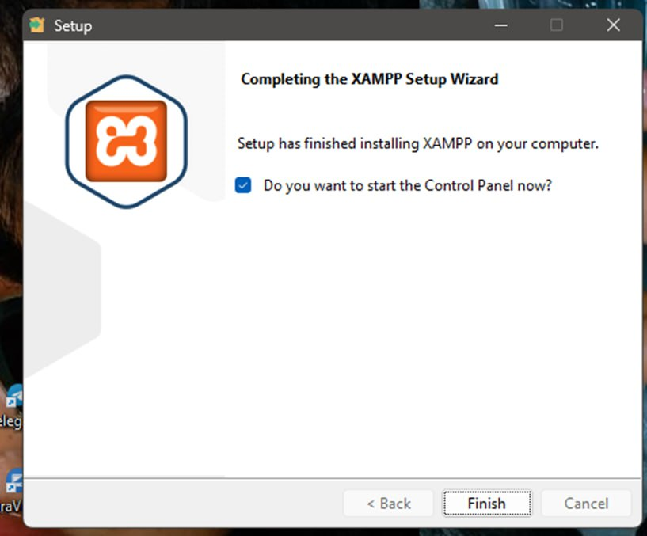
Shows the success in installing XAMPP.It provides Apache and Mysql which l will use in development.
Fig 2 :Apache and MySQL running
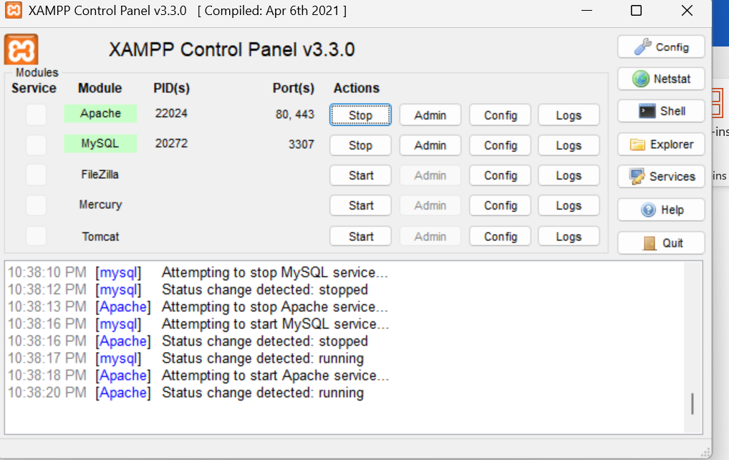
Figure shows that Apache and Mysql are running in the correct ports required in XAMPP control.This provides local server environment.
Fig 3: Localhost test page
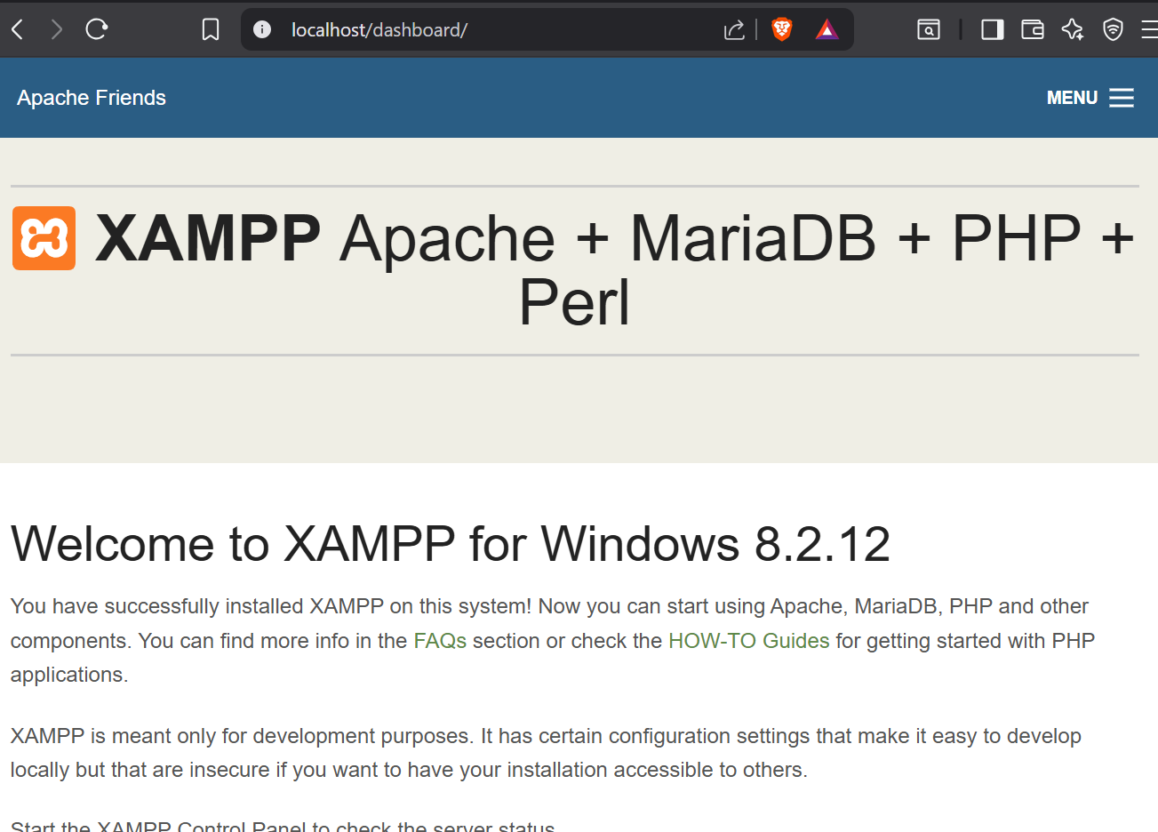
This shows that the localhos server is working correctly by displaying the page in browser
Fig 4: Hello world test

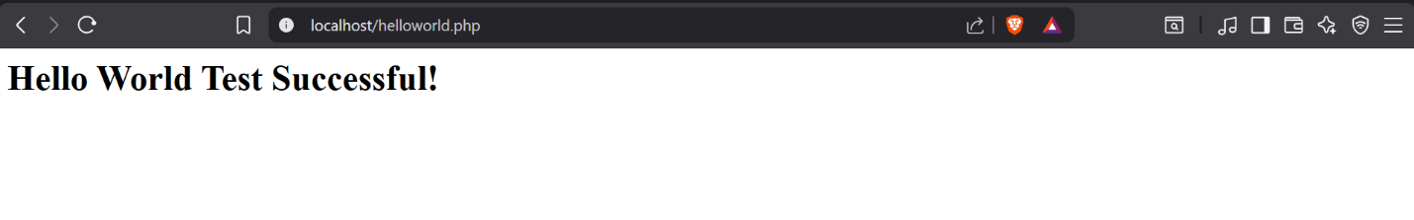This shows a PHP/HTML page used to test that the server can execute and display web pages correctly
Fig 5:Database Connection Test
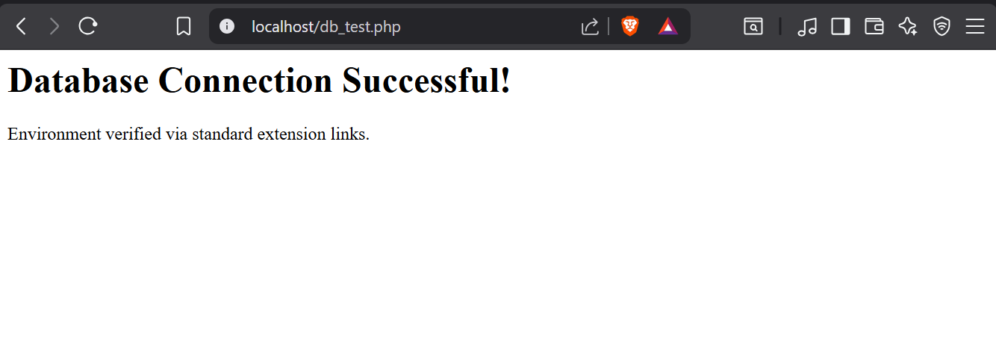
This shows successful connection of PHP and MySQL showing that Apache and MySQL were properly configured in XAMMP.
Technologies PHP + MySQL
Challenges – Connection of the database.The server was using an advanced authentication plugin(auh_gssapi_client)that PHP’s built in tools kept blocking.

Week Two: Wireframes and GUI Design
Fig 1: Wireframe (login /Homepage)Graphic representation of how the system homepage is what the users get int contact with when they search up the site.
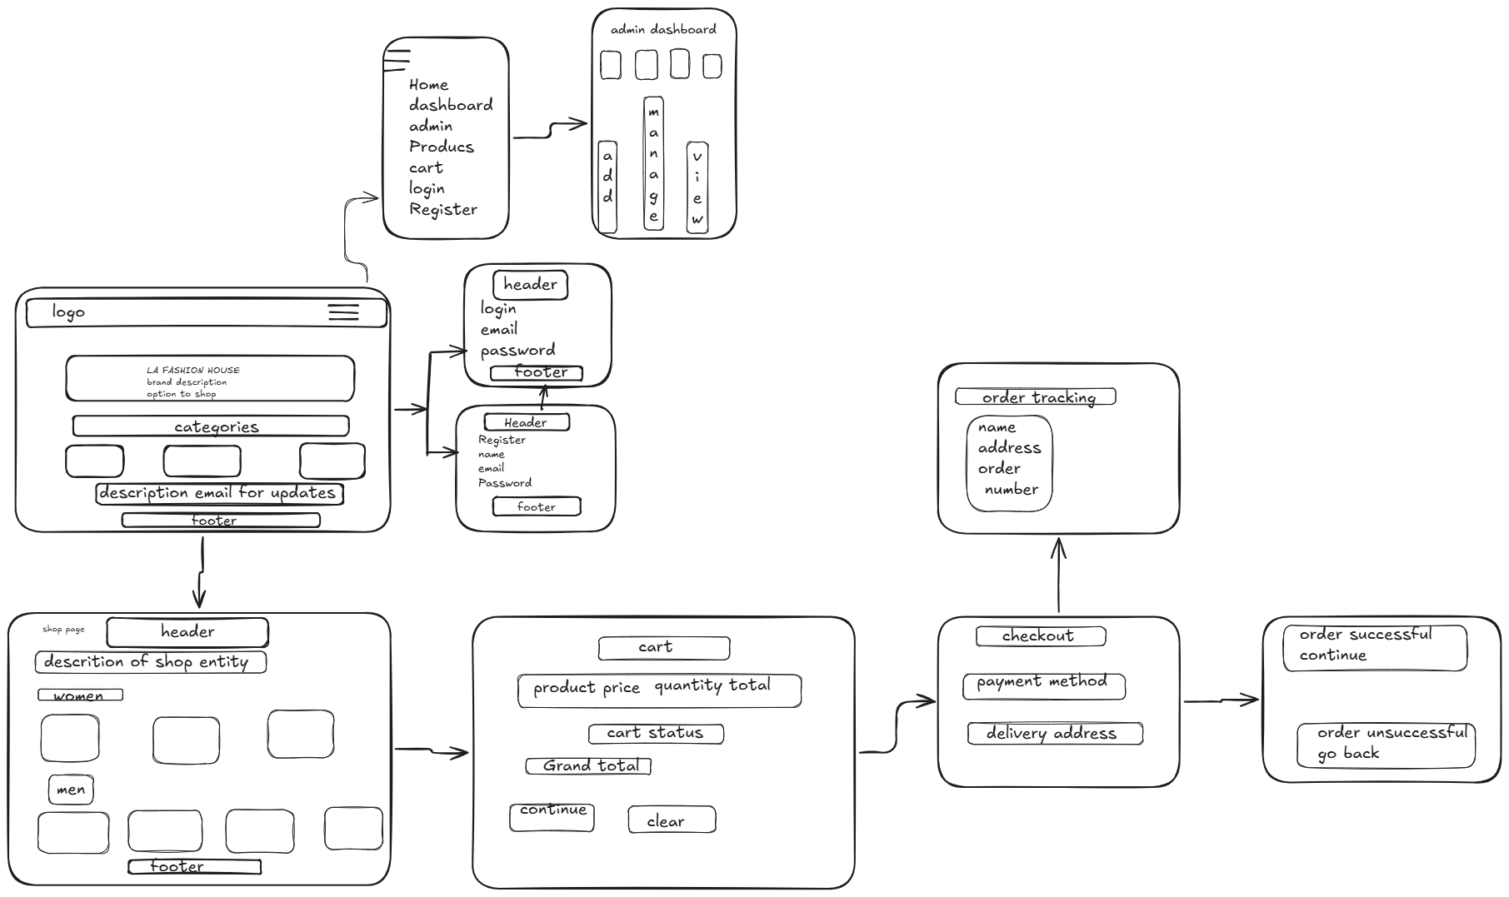
This shows the seps taken by users when using the system and of how different sessions occur. It is a blueprint of how the system will operate.

Fig 2: Dashboard Layout Design
Graphic representation of the system .Rough presentation of how the dashboard should appear and the interaction of components.

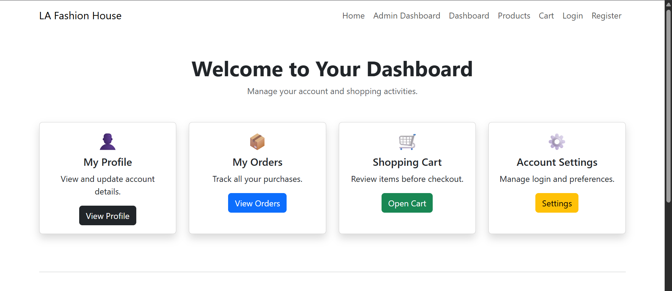This demonstrates how different sections are arranged for user usability and access
Fig 3:Mobile view mockup

This shows how the system homepage will be presented to a user.

Week 3: JavaScript and PHP Basics
Fig 1: JavaScript Form Validation
In the figure it shows the requirement to add a field inorder to move to the next stepof registration.
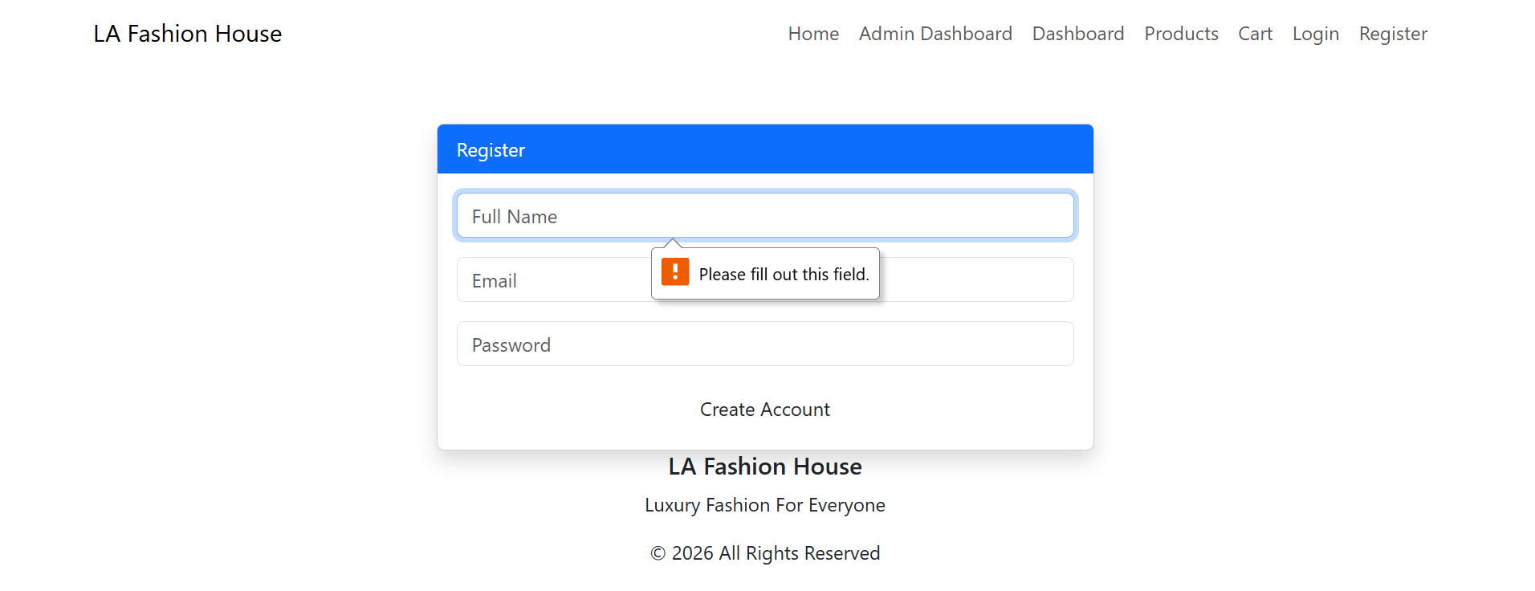
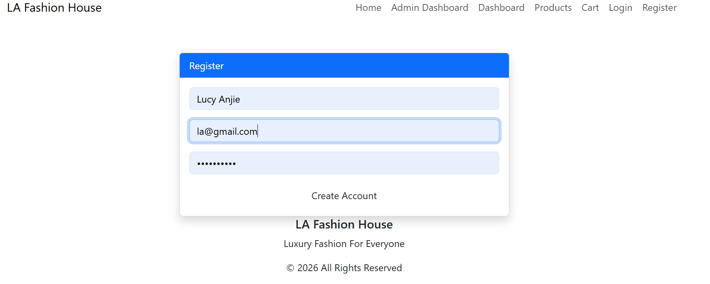
This shows that validation prevents users from submitting incorrect or empty forms.
Fig 2: Password Strength Checker
Using password checker it shows the system is able to advice on better passwords for security purposes to users and also enables one to understand when a breach is made the password was the problem.
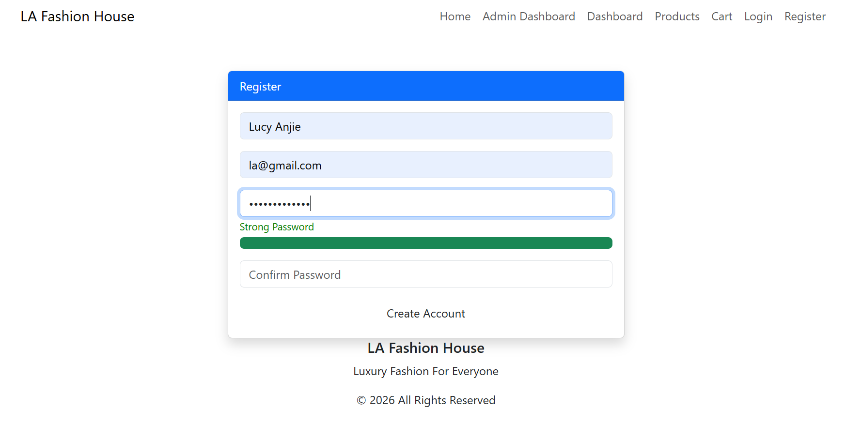
This shows the user has entered a strong password that is safe.
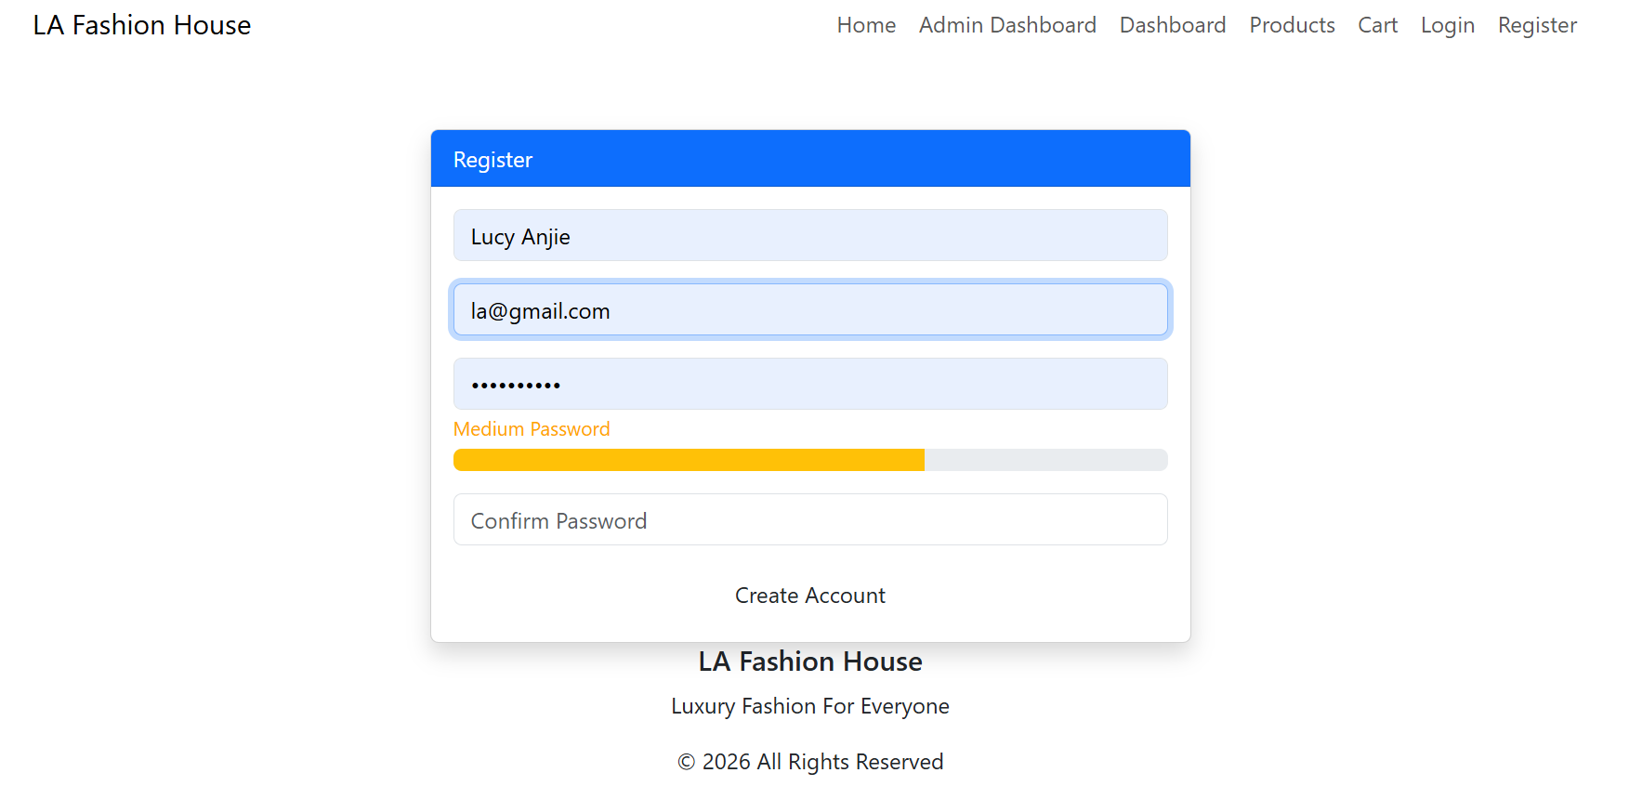
Shows th user is using a medium password which is actually vulnerable.
Fig 3: PHP Syntax Practice
Validates that the system adheres to preferred syntax method or lines in place
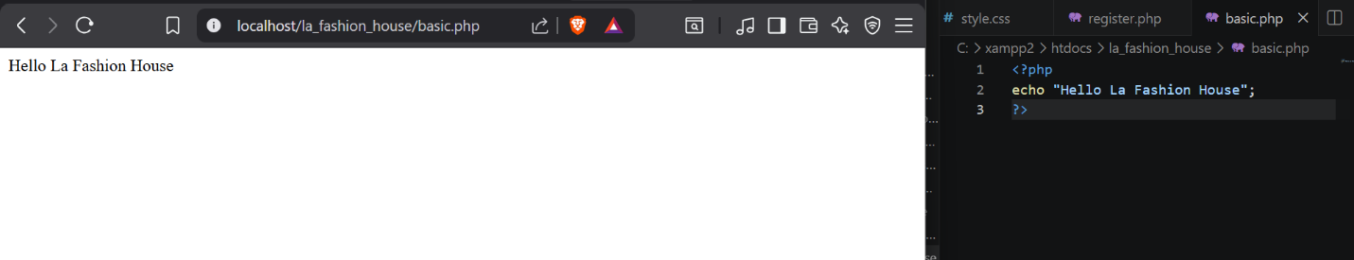

Fig 4: Database Connection Script
The connection between php and mysql .Stands to represent how database where data is stored(phpmyadmin) for the specific site ith tables .
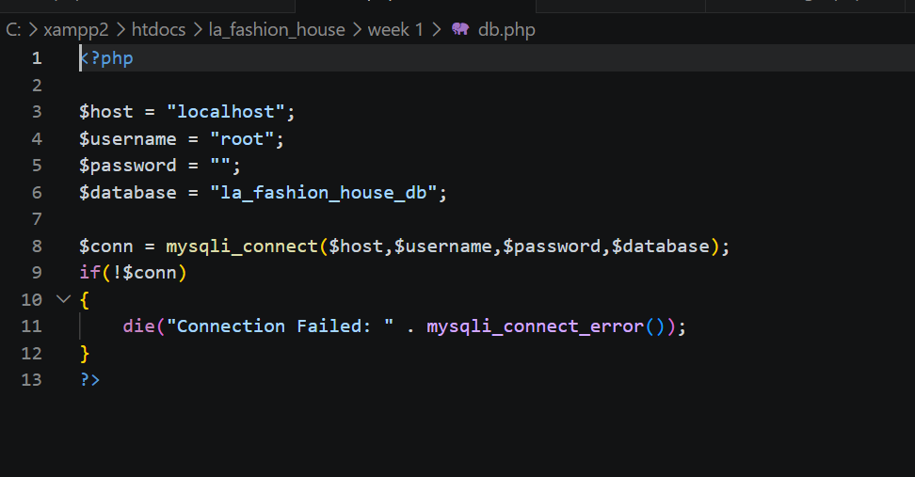
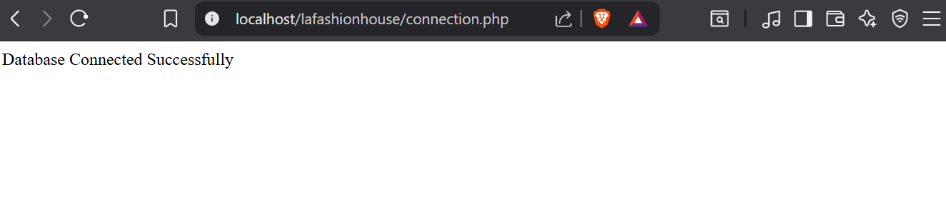One challenge I faced was fixing localhost and 404 errors (not found) while testing PHP files using XAMPP. I solved this by learning the correct folder structure inside the htdocs directory and using the correct localhost URLs.Technologies used HTML,CSS,Javascript,PHP,MySQL,XAMPP

Week 4: Simple PHP Concepts
Fig 1:Login form screenshots
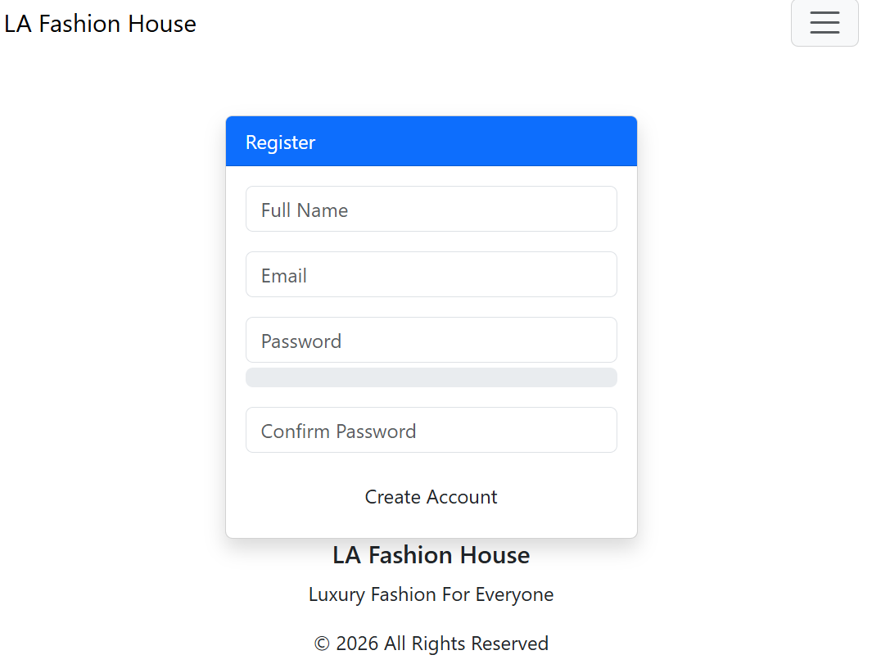
This shows the user registration form where users entre their details to be able to log in the system

Fig 2:Data submission to database
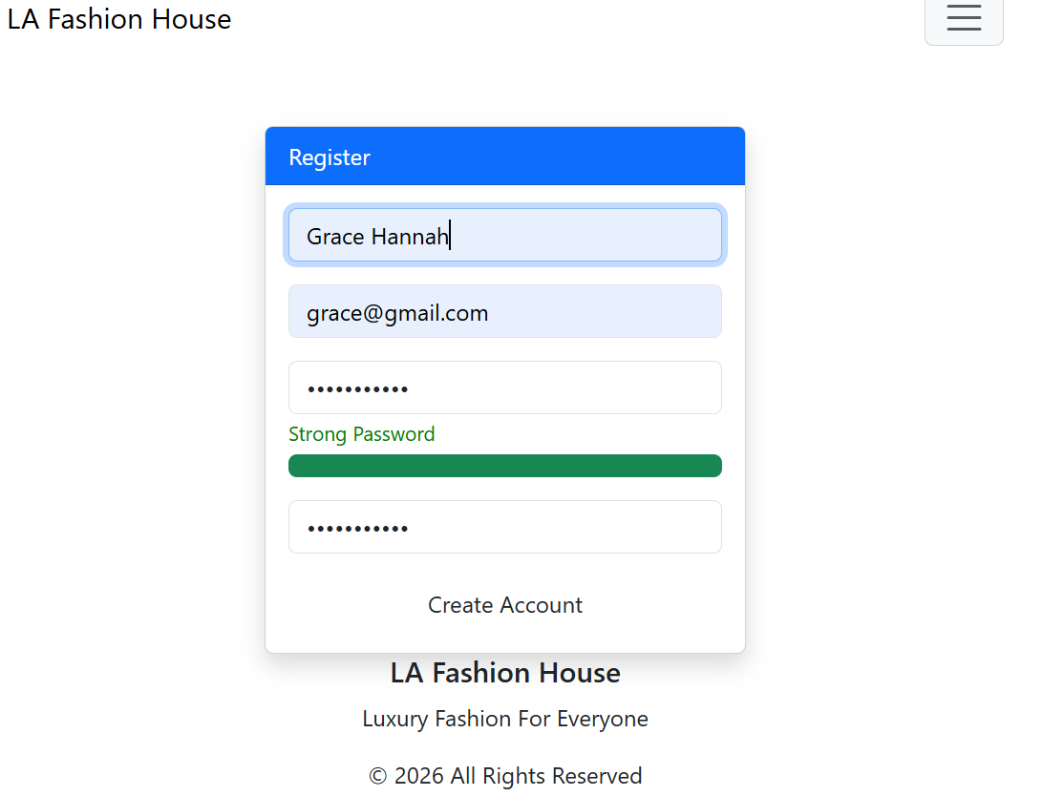
This shows how user data is submitted from the registration form and stored in the MySQL database using PHP.

Fig 3: PHP processing screenshots
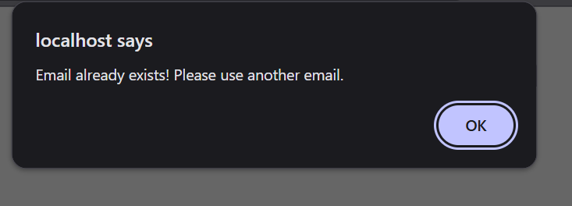
This shows that the email inserted already exixts on the daabase and the user is required to use a different one or login.
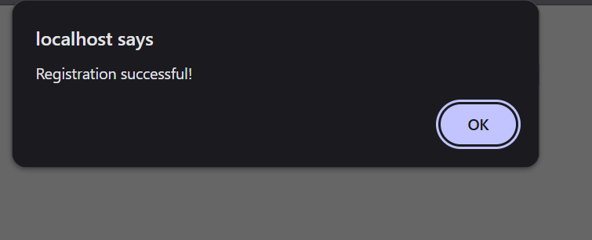
Shows that a user can register to the web store register form and their data sent to the database for storage.
Fig 4: Log in system
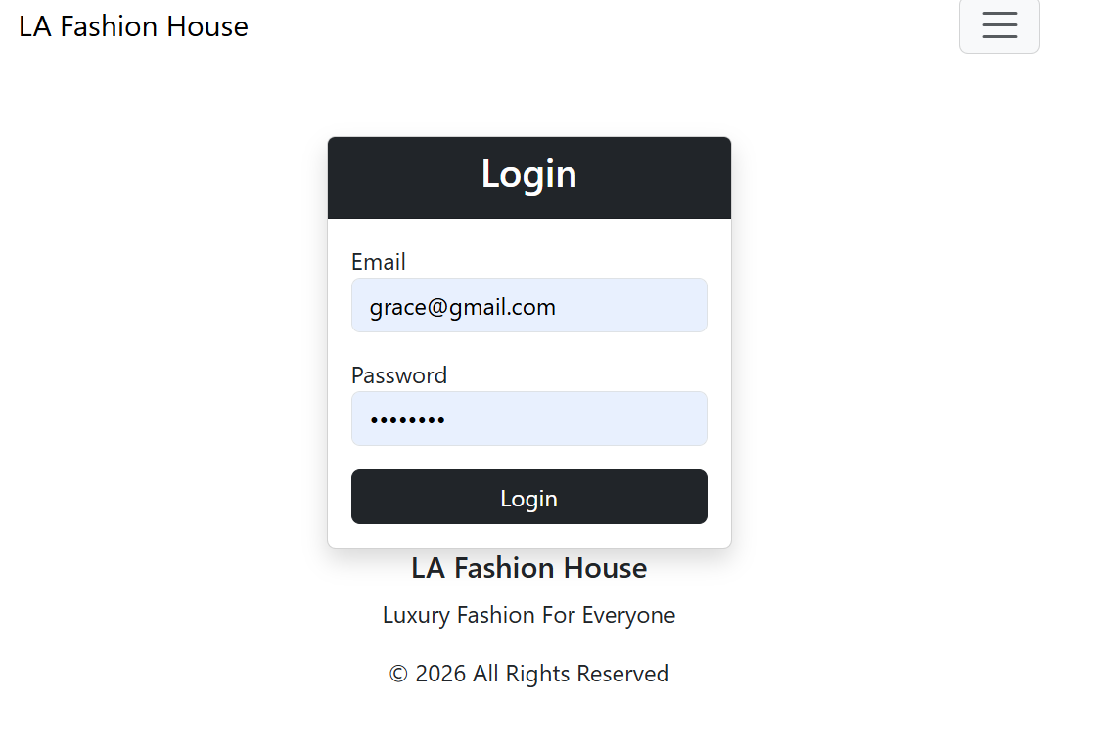
This shows how the system works when users enter their email and password.The system retrieves the user record based on the enmails and prepares for authentication.
Fig 5 :Dashboard access

This shows the user is given access to the page containing the products on sale in the store .After verification the user is given access and redirected.
Tools and technologies used PHP,MySQL,XAMPP,HTML,phpMyAdmin

Week 5: Database components and Crud operations
fig 1:Create your database (phpMyAdmin)
I created a new daabase to support the application.It consists of multiple tables such as cart,order,product and users.
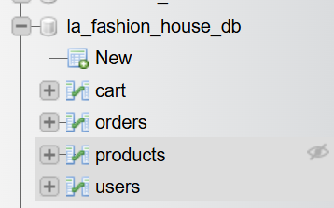
Fig 2: Create users table
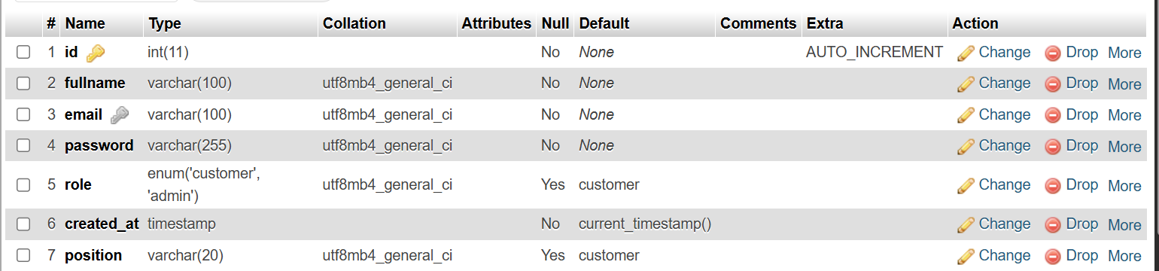
Using an SQL query l created the table which allows new data to be added in the system.This connects to the registration form which users access to register.
Fig 3:Insert sample data
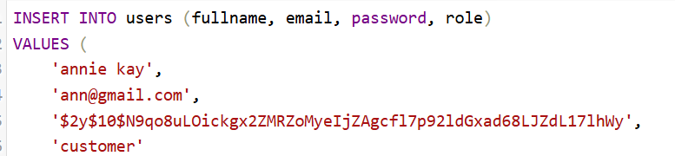
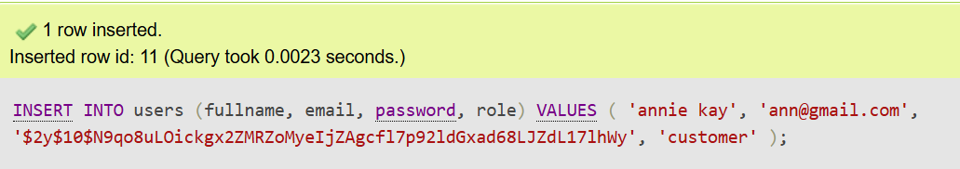
This shows the INSERT operation.I added a new user as a customer to the system.The data entered entered by a user qis collected through a form and stored in the database using SQL INSERT statement.
Fig 4: Connect PHP to database
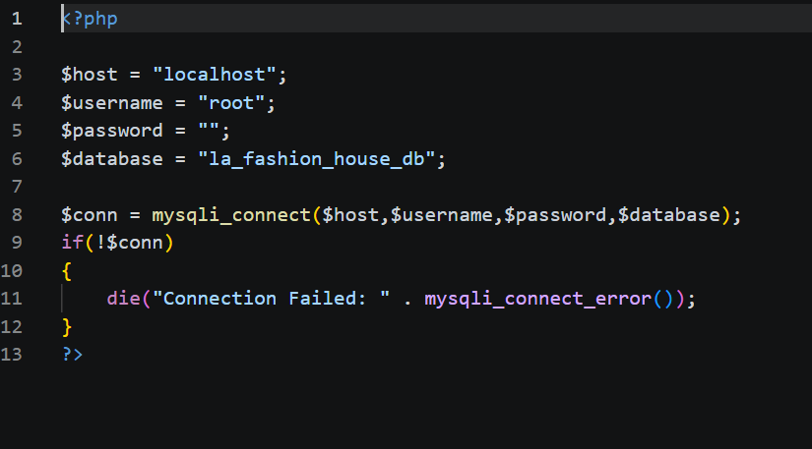
This shows the file that allows communication between the application and the database eg when a user registers.It ensures data can be stored,reviewed and manipulated dynamically.
Fig 5:READ (to display users)
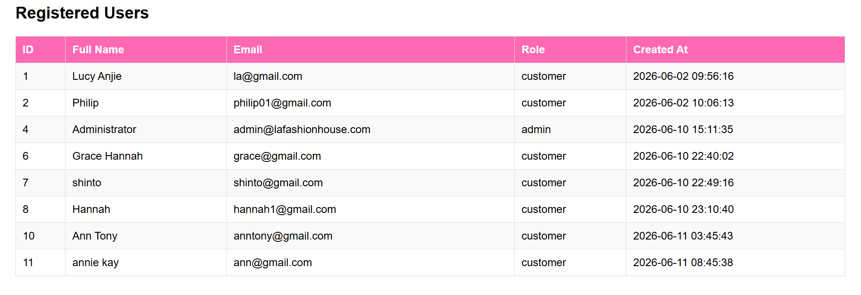
The read function operates correctly by fetching data from the database and displaying it.
Fig 6:UPDATE Data
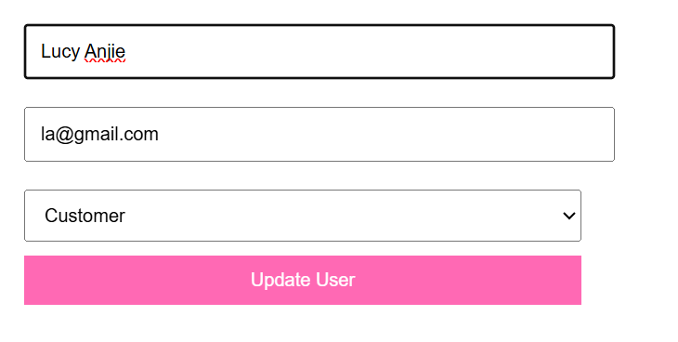
This shows a users previous role as a customer before changes.
After updating the role the user can now access the platform as an admin.
Fig 7:Delete data
This shows a column that exists before in the list on clicking delete the page will direct the user to confirm and once they confirm it is deleted.
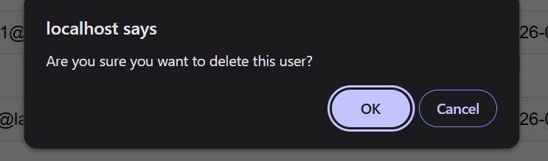
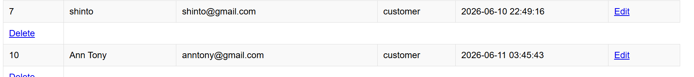
Shows column 8 is deleted.
WEEK 6 :Database integration and CRUD opertaions
Creating database
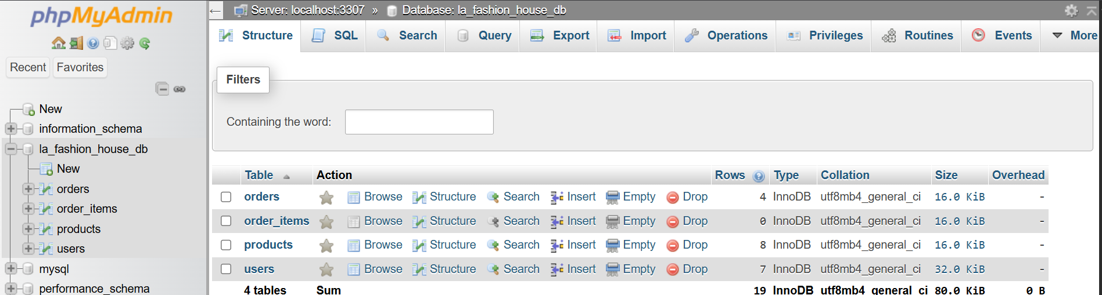
Fig1: Shows the successful creation of a database using phpmyadmin
Connecting PHP to MySQL
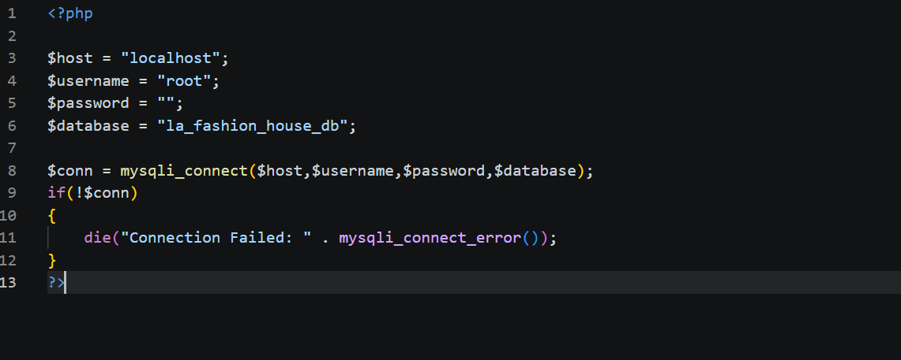
I successfully connected PHP to MySQL. This is to represent how database where data is stored(phpmyadmin) for the specific tables is connected to the system and interaction.

Creation of tables in the database
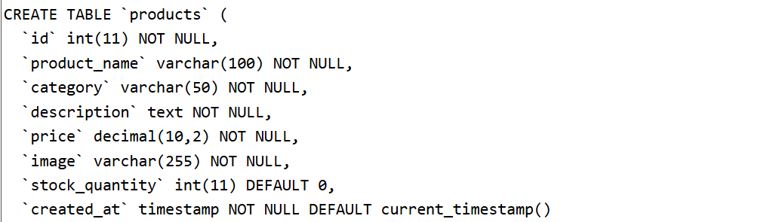
Fig 2: Shows the sql query to create a table in the database created in fig 1.This shows the specific table entries that will be viewed.
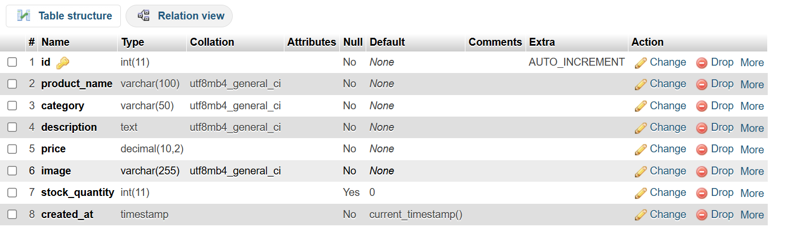
Shows the table created successfully in the database .
CREATE(Adding new product)
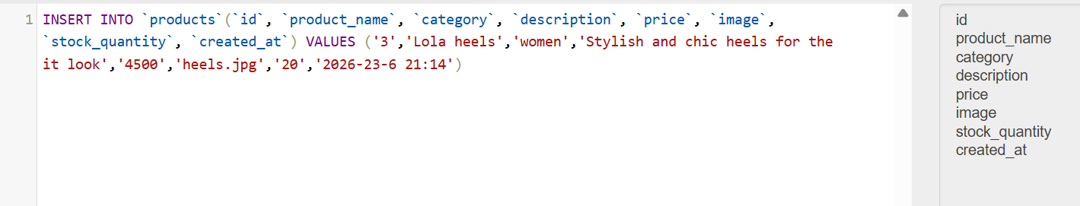


Fig 3: Shows the successful execution by an admin of adding a new product using form.It is inserted using queries in phpmyadmin and it reflects successfully on the page.

READ(Viewing product)
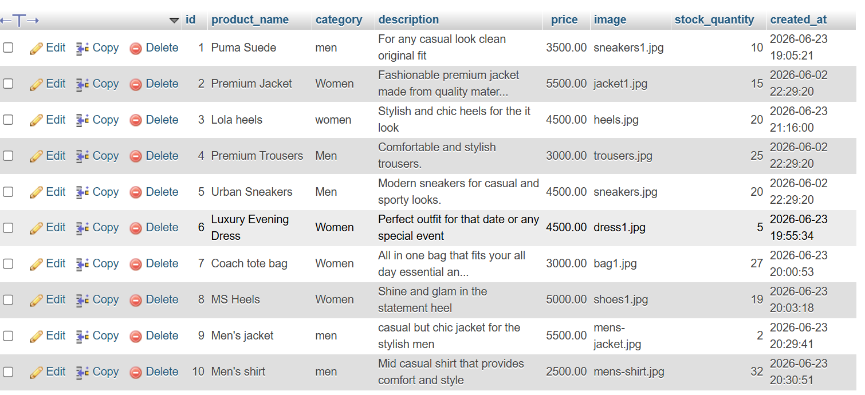


Fig4: Shows that products from the database are retrieved from the database and successfully displayed on the products page on with all categories included.

UPDATE(Edit product)
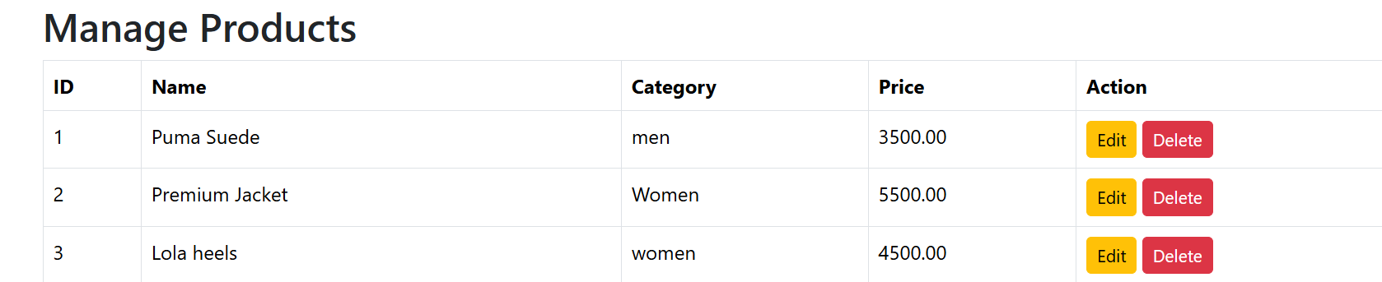
This shows that the admin has a buton dedicated t editing a product.
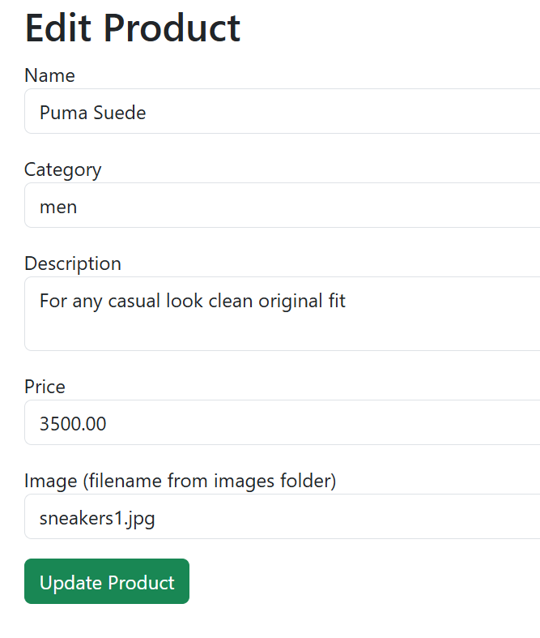.
This shows the form where the admin can edit specifics about the product.
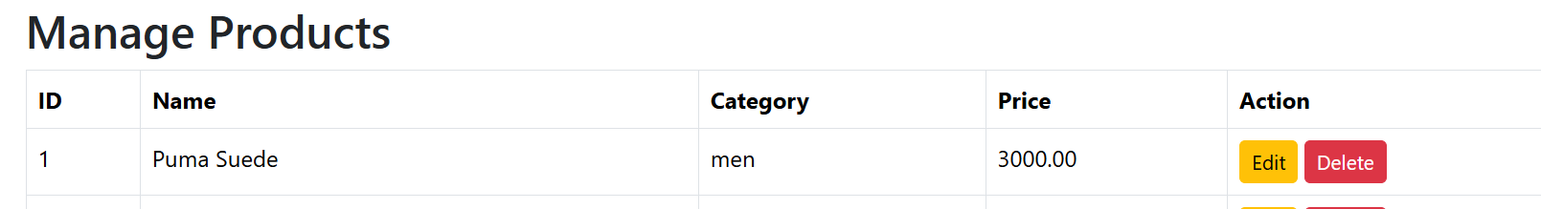
Shows the edited price of the product from 3500 to 3000.This shows the admin has the flexibility to change product details at preference.

The SQL UPDATE statement is used to modify the existing records in the database.This ensures that product information remains accurate and upto date.
DELETE(Deleting product)

Shows the admin is able to delete a product with a button indication for it.

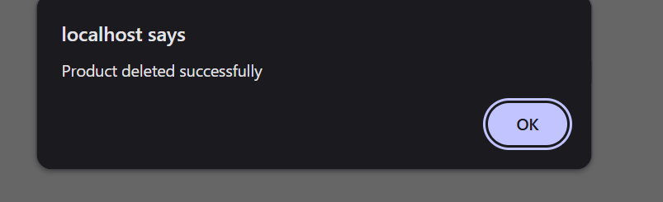
Shows the product was deleted successfully from the page.
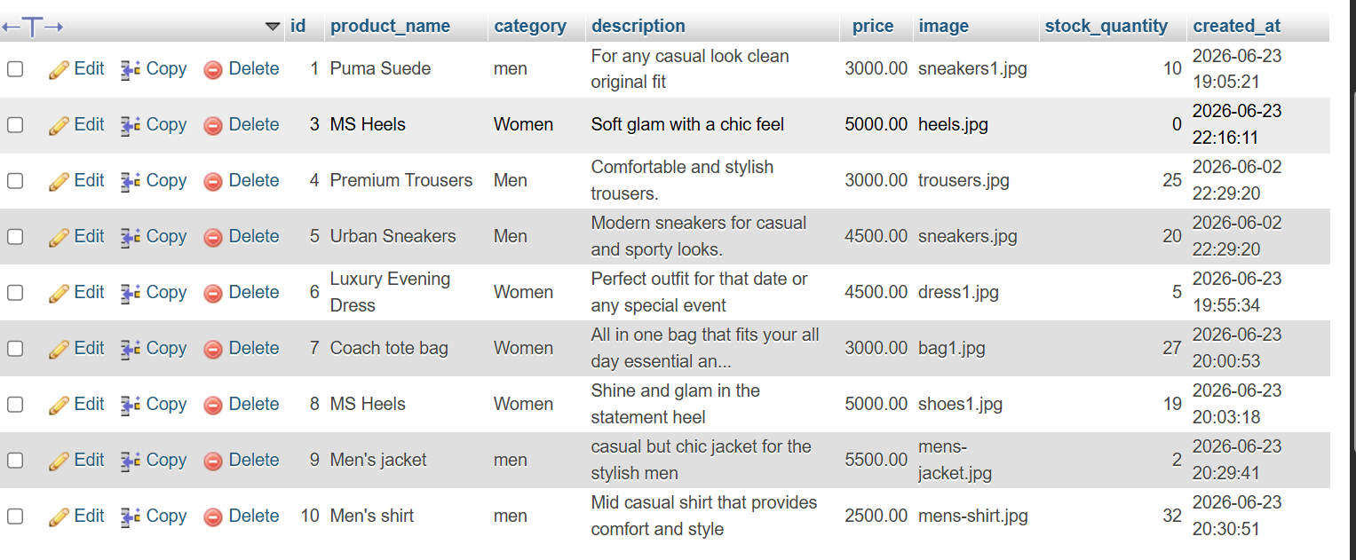
Shows the successful deletion of product 2 from the database.

Week 7 :User authentication and session management
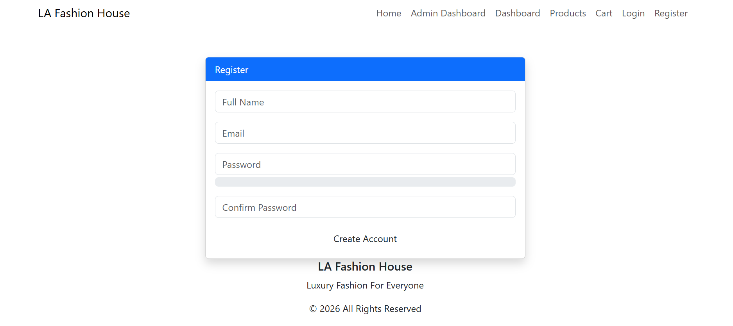
Fig1: The figure shows the user registration form where new users sign up to the system upon filling required fields the passwords are hashed before storing in the database.
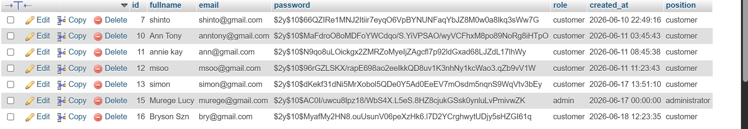
Fig2: This shows the users table in the database after registration.It shows the hashed passwords and user roles according to how they registered to the system.
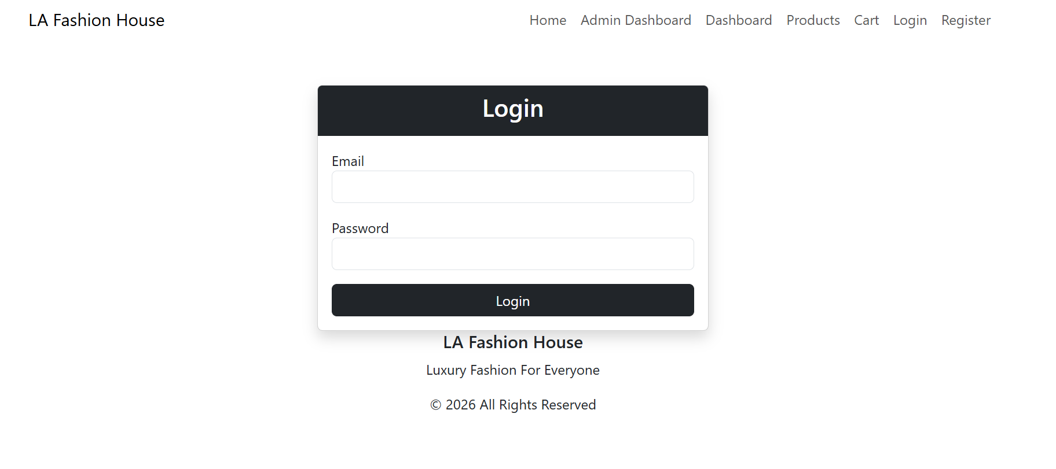

Fig3:The figure shows the log in page where registered users log in to access the system.

Fig4:This shows the home page after a user successfully logs in.
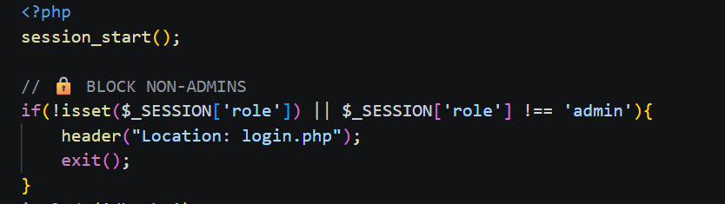
Fig5:The figure shows the admin_dashboard.php code that shows only the admin can access the page upon log in.
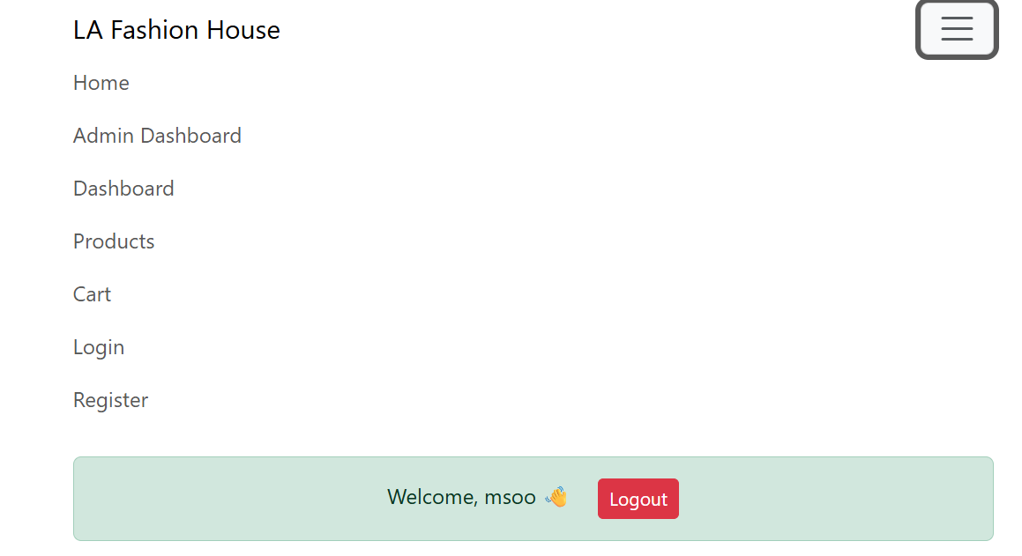

Fig6:This shows when a user logs in as a customer and tries to access the admin dashboard they are redirected to the log in page(denial of entry)
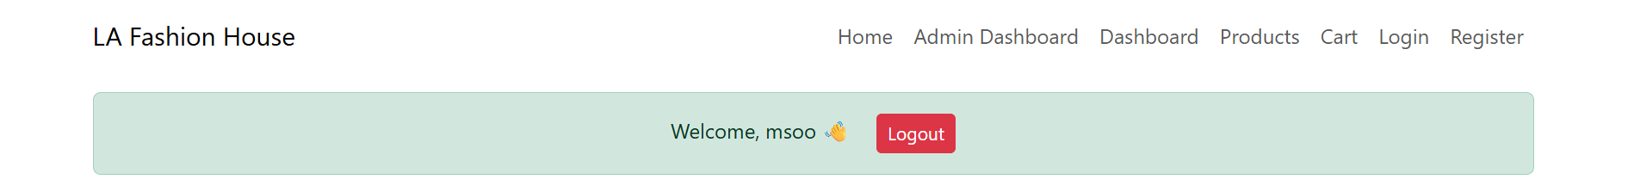

Fig7:The figure shows the log out functionality the session is destroyed and the user is redirected to the log in page.
Week 8:Responsive web design and mobile first development

Fig 1:This shows that the system is functional before any altercations for the mobile responsiveness.

Fig2:Shows the viewport meta tag used to ensure proper scaling and responsiveness on different devices.
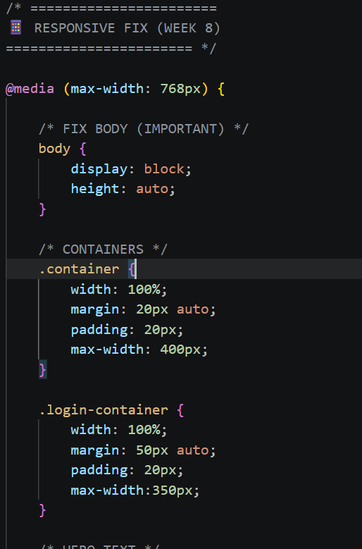
Fig3:This shows tha modification of my style.css code to include the improving of the responsiveness and appearance.
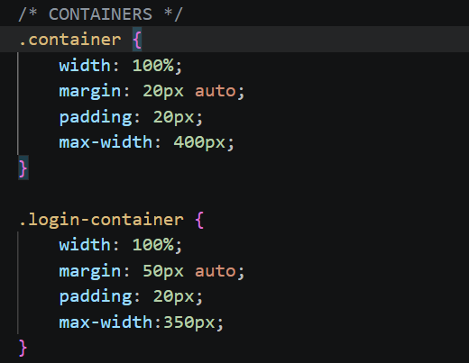
Fig4: This shows the implementation of CSS media queries to support different screen sizes.

Fig5:This shows the testing of the mobile responsiveness on a mobile device .The testing showed fulll functionality of the system on a mobile phone.
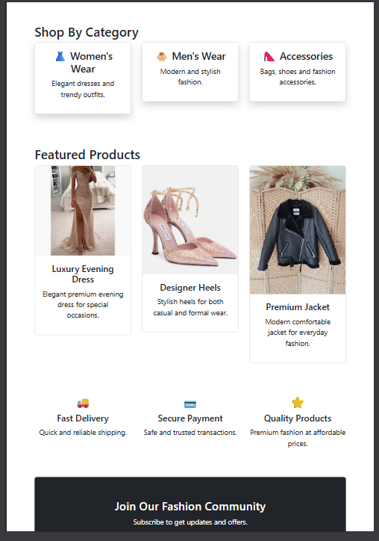
Fig 6&7:This shows the view of the page on a tablet screen dimension.It shows that a user can browse trough easily with the page still interactive.

Fig8:Shows the appearance of the website on a desktop.I tested its responsiveness in all the three mentioned dimensions and it proved to function.
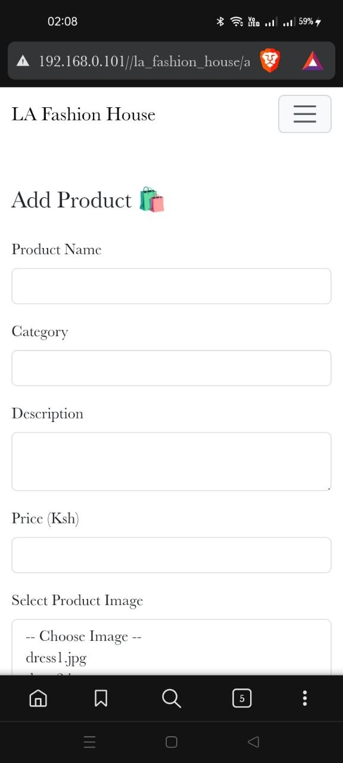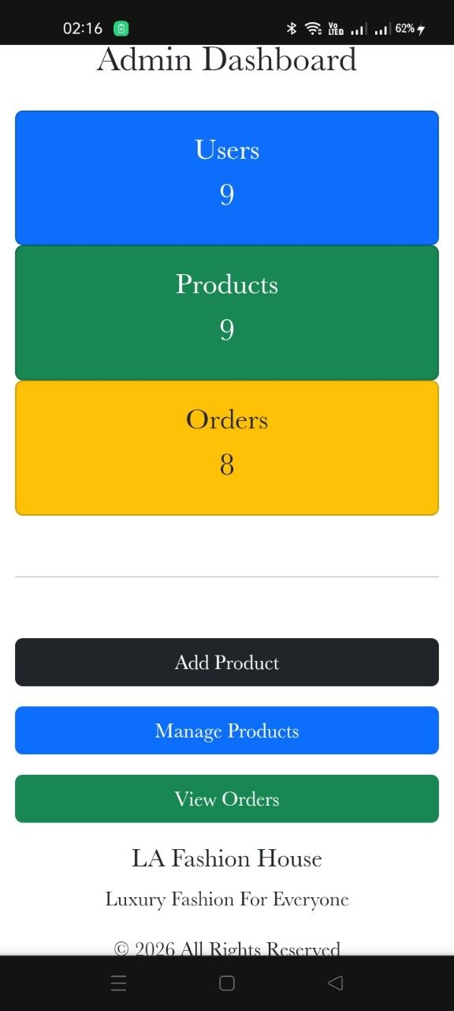
Fig9:This image shows that the admin functionality is responsive on any device.The admin can easily access logs to add,manage and view orders on any device.

Fig10:This shows the responsiveness of the products page on differenet dimension where on a mobile it is one device at a time while in a tablet its four at a go.
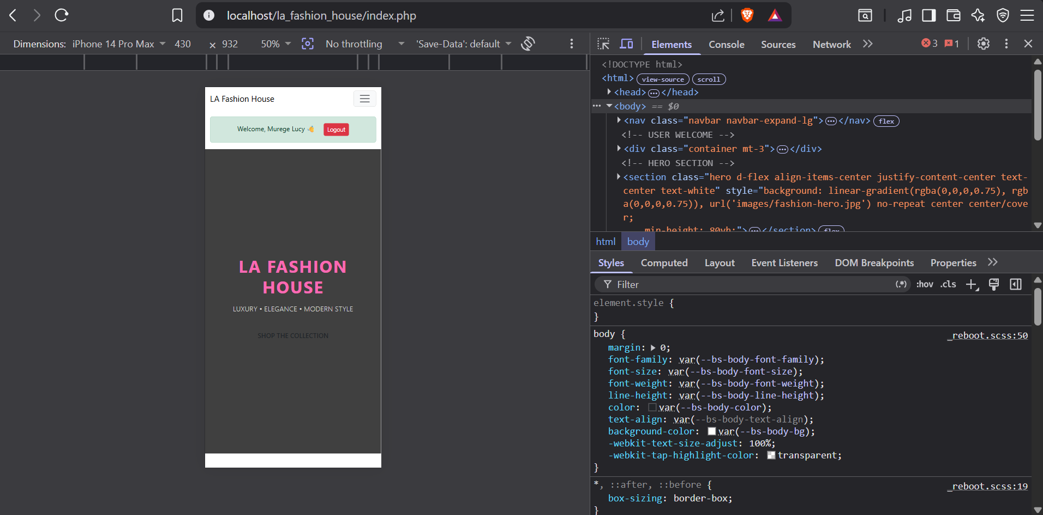
Fig 10:Shows the website test for responsiveness using braveDevTools.Different screen sizes such as mobile table and desktop are simulated .

